**Variables & Names:**

In programming, a variable is a container for storing data values. These values can be changed throughout the program. When you create a variable, you give it a name, which is used to reference it later in your code.

**String Basics:**

Strings are sequences of characters, enclosed within either single quotes (' ') or double quotes (" "). They are used to represent text data in Python.

**List, Tuple, Set, Dictionaries:**

These are different data structures in Python used to store collections of items.

**List:** Ordered and mutable collection of items. Denoted by square brackets [ ].

**Tuple:** Ordered and immutable collection of items. Denoted by parentheses ( ).

**Set:** Unordered and mutable collection of unique elements. Denoted by curly braces { }. Sets do not maintain the order of elements and do not allow duplicate values. They support various operations such as union, intersection, difference, and symmetric difference, making them useful for tasks involving unique elements and set operations.

**Dictionary:** Unordered collection of key-value pairs. Denoted by curly braces { }.

**Conditional Statements:**

Conditional statements are used to execute different blocks of code based on whether a specified condition evaluates to true or false.

**if statement:** Executes a block of code if the condition is true.

**if-else statement:** Executes one block of code if the condition is true and another block if it's false.

**if-elif-else statement:** Executes different blocks of code for different conditions.

**Loop**

**For Loop:** Used for iterating over a sequence (such as a list, tuple, string, or range) or other iterable objects. It executes a block of code a fixed number of times.

**While Loop:** Executes a block of code as long as a specified condition is true. It continues looping until the condition becomes false.

**Functions:**

* A function is a block of reusable code that performs a specific task.
* It takes input parameters (arguments), performs operations, and optionally returns a result.
* Functions help in organizing code, improving readability, and reusability.

**Common Errors in Python:**

* **Syntax Errors:** Mistakes in the code structure that violate the language syntax rules.
* **Runtime Errors (Exceptions):** Errors that occur during program execution, such as division by zero, index out of range, etc.
* **Logical Errors:** Errors where the code runs without crashing but produces incorrect results due to flawed logic.

**List Comprehension:**

* List comprehension is a concise way to create lists in Python.
* It provides a compact syntax to generate lists from existing iterables or perform transformations on elements.

**File Handling:**

* File handling in Python allows you to read from and write to files.
* You can open files using the open() function, which returns a file object.
* Operations like reading, writing, and closing files can be performed using methods of the file object.

**Lambda, Filters, and Map:**

**Lambda Functions:** Also known as anonymous functions, lambda functions are small, anonymous functions defined using the lambda keyword. They are typically used where a simple function is needed temporarily.

**Filter:** The filter() function filters elements of an iterable based on a specified condition, returns an iterator containing only the elements that satisfy the condition. The function passed to filter() should return **True** for elements that should be included in the filtered result and **False** for elements that should be excluded.

**example:**

numbers = [1, 2, 3, 4, 5, 6]

evens = list(filter(lambda x: x % 2 == 0, numbers))

print(evens)  # Output: [2, 4, 6]

**Map:** The map() function applies a given function to each item of an iterable (such as a list) and returns an iterator with the results. Is used to apply a function to each element of an iterable and transform each element in some way.

**example:**

numbers = [1, 2, 3, 4, 5]

squares = list(map(lambda x: x**2, numbers))

print(squares)  # Output: [1, 4, 9, 16, 25]

**Debugging in Python:**

* Debugging is the process of identifying and fixing errors, or bugs, in your code.
* Python provides several tools for debugging, including:
  + **print statements:** Inserting print statements at key points in your code to inspect variable values and control flow.
  + **Python Debugger (pdb):** The built-in debugger module allows you to step through your code line by line, inspecting variables and executing code interactively.
  + **IDEs and Text Editors**: Integrated Development Environments (IDEs) like PyCharm, Visual Studio Code, or editors like Sublime Text and Atom provide debugging tools such as breakpoints, watches, and variable inspectors.

**Class and Objects:**

* **Class:** A class is a blueprint for creating objects (instances) with shared attributes and behavior.
* **Object:** An object is an instance of a class, representing a specific entity with its own unique attributes and methods.
* Classes encapsulate data (attributes) and behavior (methods) into a single unit.
* Attributes are variables that store data within an object, while methods are functions that operate on the object's data.

**Regular Expressions:**

* Regular Expressions (regex): Regex is a powerful tool for searching, extracting, and manipulating text based on patterns.
* Python's re module provides support for working with regular expressions.
* Common regex operations include searching for patterns, matching strings, replacing text, and splitting strings.

**example:**

import re

text = "Hello, my email is example@email.com"

pattern = r'\b[A-Za-z0-9._%+-]+@[A-Za-z0-9.-]+\.[A-Z|a-z]{2,}\b'

emails = re.findall(pattern, text)

print(emails)  # Output: ['example@email.com']

**Python PIP:**

PIP stands for "Python Installer Package". It's a package management system used to install and manage software packages written in Python. PIP comes bundled with Python, so if you have Python installed, you likely already have PIP.

* Installing a package: **pip install package_name**
* Installing a specific version of a package: **pip install package_name==version_number**
* Upgrading a package: **pip install --upgrade package_name**
* Uninstalling a package: **pip uninstall package_name**

**Read Excel Data in Python:**

To read Excel data in Python, you can use the pandas library. Pandas provides a convenient way to handle Excel files.

import pandas as pd

# Read Excel file

df = pd.read_excel('filename.xlsx')

**Iterators:**

Iterators in Python are objects that allow you to traverse through all the elements of a collection (like lists, tuples, etc.) or a sequence (such as a string) one by one.

my_list = [1, 2, 3, 4, 5]

my_iter = iter(my_list)

# Print each element of the list using the iterator

for item in my_iter:

    print(item)

**Pickling:**

Pickling is the process of serializing Python objects into a byte stream. This byte stream can be stored in a file or sent over a network. Pickling allows you to save the state of your Python objects to reuse later or share with others.

import pickle

# Object to be pickled

data = {'a': 1, 'b': 2, 'c': 3}

# Pickle the object

with open('data.pickle', 'wb') as f:

    pickle.dump(data, f)

# Unpickle the object

with open('data.pickle', 'rb') as f:

    loaded_data = pickle.load(f)

print(loaded_data)  # Output: {'a': 1, 'b': 2, 'c': 3}

**Python JSON:**

JSON (JavaScript Object Notation) is a lightweight data interchange format that is easy for humans to read and write and easy for machines to parse and generate. Python has a built-in module called json that allows you to work with JSON data.

import json

# Python object (dictionary) to JSON string

data = {'name': 'John', 'age': 30, 'city': 'New York'}

json_string = json.dumps(data)

print(json_string)

# JSON string to Python object (dictionary)

python_obj = json.loads(json_string)

print(python_obj)

**Algorithm Efficiency and time complexity**

Algorithm efficiency and complexity are essential concepts in computer science that help in evaluating and comparing different algorithms based on their performance and resource usage. Let's break down these concepts:

**Algorithm Efficiency:**

Algorithm efficiency refers to how well an algorithm solves a particular problem. An efficient algorithm typically consumes fewer resources (such as time and memory) and produces the desired output quickly. Efficiency is subjective and can vary based on different criteria like time complexity, space complexity, and readability.

**Algorithm Complexity:**

Algorithm complexity is a measure of the amount of computational resources required by an algorithm. There are two main types of complexity:

**Time Complexity:** Time complexity represents the amount of time an algorithm takes to run as a function of the length of the input. It's usually expressed using Big O notation, which provides an upper bound on the growth rate of the algorithm as the size of the input increases. For example, an algorithm with a time complexity of O(n) means its runtime grows linearly with the size of the input (n), O(n^2) means quadratic time complexity, and so on.

**Space Complexity:** Space complexity refers to the amount of memory space required by an algorithm to execute as a function of the length of the input. Like time complexity, it's also expressed using Big O notation. An algorithm with a space complexity of O(n) means it uses memory proportional to the size of the input.

**Evaluating Efficiency and Complexity:**

When evaluating the efficiency and complexity of an algorithm, it's essential to consider both time and space requirements. A good algorithm strikes a balance between these factors, aiming for minimal time and space complexity while maintaining readability and maintainability.

**Example:**

Let's consider a simple example to illustrate these concepts. Suppose we have two algorithms for sorting an array of integers: Bubble Sort and Merge Sort.

* Bubble Sort has a time complexity of O(n^2) and a space complexity of O(1). It's simple but inefficient, especially for large datasets.
* Merge Sort, on the other hand, has a time complexity of O(n log n) and a space complexity of O(n). It's more efficient, particularly for large datasets, but requires more memory.

In this example, Merge Sort is more efficient in terms of time complexity, making it a better choice for large datasets, even though it requires more memory than Bubble Sort.

**Conclusion:**

Understanding algorithm efficiency and complexity is crucial for designing and analyzing algorithms effectively. By considering factors like time complexity and space complexity, you can choose the most suitable algorithm for your problem based on your specific requirements and constraints.

**Example algorithms**

**1.Binary Search:**

* Binary Search is a search algorithm used to find the position of a target value within a sorted array or list.
* It works by repeatedly dividing the search interval in half until the target value is found or the interval becomes empty.
* Binary search requires the list to be sorted in ascending order.
* The time complexity of binary search is O(log n), making it significantly faster than linear search for large lists.
* Here's a basic outline of the binary search algorithm:
  1. Initialize low and high indices to the first and last elements of the list, respectively.
  2. While the low index is less than or equal to the high index:
     + Calculate the mid index as the average of low and high.
     + If the target value is equal to the element at the mid index, return the mid index.
     + If the target value is less than the element at the mid index, update the high index to mid - 1.
     + If the target value is greater than the element at the mid index, update the low index to mid + 1.
  3. If the target value is not found, return -1 or indicate that the element is not present in the list.

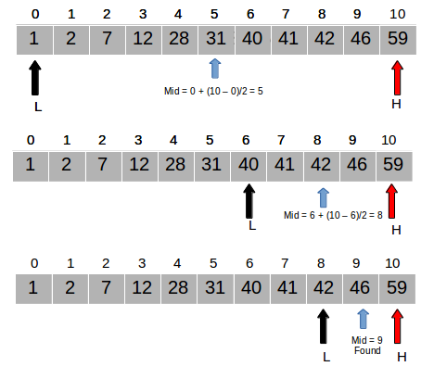 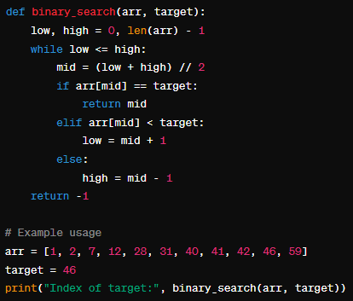

**2.Euclid's Algorithm:**

* Euclid's Algorithm is used to find the greatest common divisor (GCD) of two integers.
* It is based on the principle that the GCD of two numbers does not change if the larger number is replaced by its difference with the smaller number.
* Euclid's Algorithm is recursive in nature and has a time complexity of O(log n), making it efficient for finding the GCD of large numbers.
* Here's a basic outline of Euclid's Algorithm:
  + Given two integers a and b:
    - If b is 0, the GCD of a and b is a.
    - Otherwise, recursively compute the GCD of b and the remainder of a divided by b (a % b).

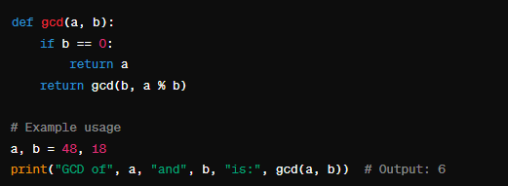

**Data Structures**

**Tree:**

A tree is a hierarchical data structure consisting of nodes connected by edges. It resembles a tree in nature, with a single node called the root that has zero or more child nodes. Each child node can have its own children, forming a hierarchical structure. Nodes in a tree are often referred to as parent, child, or sibling nodes.

**Key Components:**

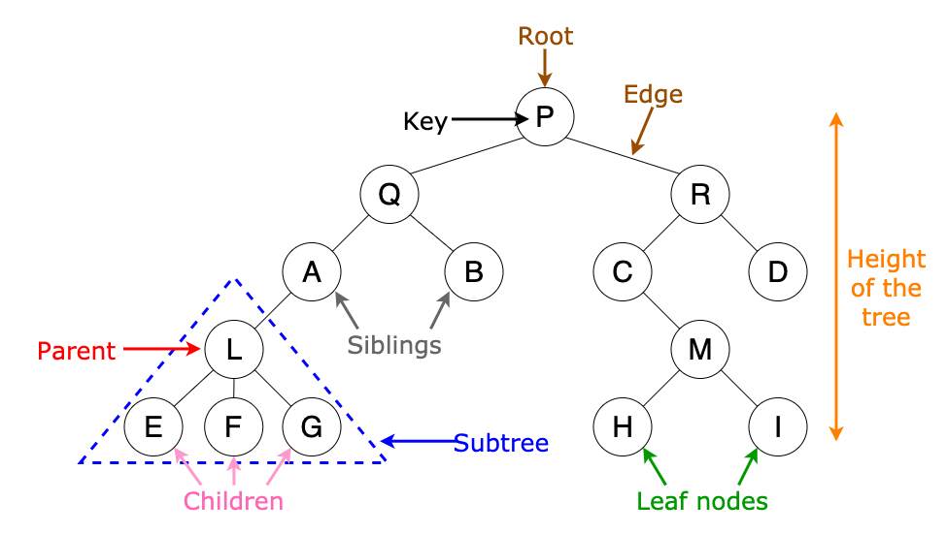

**Root:** The topmost node in a tree. It is the starting point for traversing the tree.

**Node:** Each element in a tree data structure.

**Edge:** The connection between two nodes.

**Parent Node:** A node from which other nodes originate.

**Child Node:** A node that is connected to a parent node.

**Leaf Node:** A node with no children.

**Subtree:** A portion of the tree that can be treated as a complete tree itself.

**Depth:** The level of a node in the tree, starting from the root.

**Height:** The maximum depth of any node in the tree.

Trees have various applications in computer science, such as representing hierarchical data like file systems, organizing data for efficient searching (e.g., binary search trees), and implementing data structures like heaps and priority queues.

**Linked List:**

Introduction:

A linked list is a linear data structure where elements are stored in nodes. Each node contains data and a reference (or pointer) to the next node in the sequence. Linked lists come in two main flavors: singly linked lists, where each node points to the next node, and doubly linked lists, where each node has references to both the next and previous nodes.

**Key Components**:

**Node:** Represents an element in the linked list. Contains the actual data and a reference to the next node (and optionally, the previous node in a doubly linked list).

**Head:** Points to the first node in the linked list. Serves as the starting point for traversing the list.

**Tail (for doubly linked lists):** Points to the last node in the linked list. Facilitates efficient insertion at the end of the list.

**Next Pointer:**Indicates the reference to the next node in the sequence. Allows traversal from one node to the next.

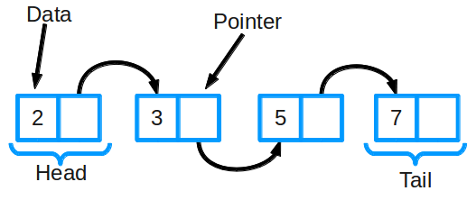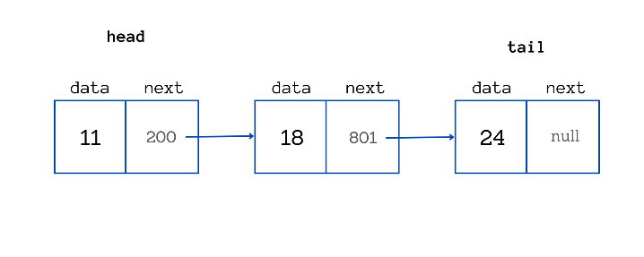

Conclusion:

Linked lists offer dynamic memory allocation and efficient insertion/deletion operations, especially at the beginning or middle of the list. They are suitable for scenarios where the size of the data structure may change frequently or when random access to elements is not required. However, linked lists may consume more memory due to the overhead of maintaining node pointers, and accessing elements by index may require traversing the list from the beginning, resulting in slower performance compared to arrays.

**Queue:**

Introduction:

A queue is a linear data structure that follows the **First-In, First-Out (FIFO)** principle. It represents a collection of elements where new elements are added at one end (rear) and existing elements are removed from the other end (front). Queues are commonly used in scenarios such as task scheduling, process management, and breadth-first search algorithms.

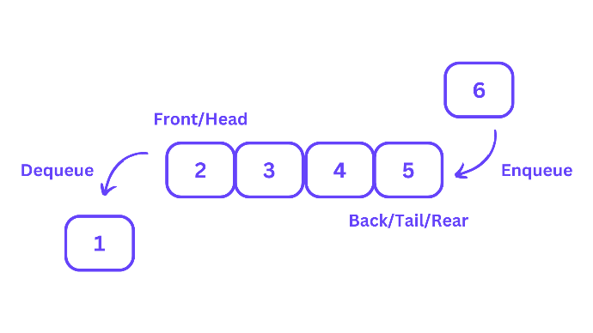**Key Components:**

**Front:** Points to the front (or head) of the queue. Represents the position from which elements are dequeued (removed).

**Rear:** Points to the rear (or tail) of the queue.

Represents the position where new elements are enqueued (added).

**Enqueue Operation:** Adds an element to the rear of the queue.

**Dequeue Operation:** Removes and returns the element from the front of the queue.

Conclusion:

Queues provide an efficient way to manage data processing and ensure that tasks are executed in the order they were added. They are particularly useful in scenarios where elements must be processed sequentially, such as in task scheduling and managing resources. However, queues may have a limited capacity depending on the implementation, and accessing elements at arbitrary positions within the queue is not supported. Additionally, implementing queues using arrays may result in inefficient memory management due to the need for resizing the underlying array.

**Stack:**

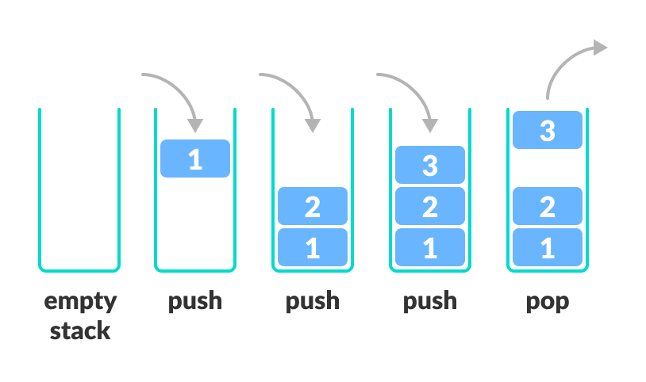A stack is a linear data structure that follows the **Last In, First Out (LIFO)** principle. It is similar to a stack of plates where the last plate placed on top is the first one to be removed. A stack has two primary operations: push and pop.

**Key Operations:**

**Push:** Adds an element to the top of the stack.

**Pop:** Removes and returns the element from the top of the stack.

**Peek (or Top):** Returns the element at the top of the stack without removing it.

**IsEmpty:** Checks if the stack is empty.

**Size:** Returns the number of elements in the stack.

Stacks are used in various applications, including implementing function calls and recursion in programming languages, parsing expressions in compilers, and managing undo functionality in text editors. They provide a simple and efficient way to manage data where the order of operations is important.

**Memory Management/Technologies**:

Basics:

1. **Automatic Memory Management:** Python uses automatic memory management which means that memory is allocated and deallocated as needed. Developers don't need to explicitly allocate or deallocate memory.
2. **Garbage Collection:** Python's garbage collector handles the deallocation of memory for objects that are no longer referenced. It uses reference counting and a cyclic garbage collector to manage memory efficiently.

Best Practices:

1. **Avoid Circular References:** Circular references can prevent objects from being garbage collected, leading to memory leaks. Be mindful of creating circular references, especially in long-lived objects.
2. **Use Generators for Large Datasets:** When dealing with large datasets, consider using generators instead of lists to avoid loading the entire dataset into memory at once.
3. **Profile Memory Usage:** Use tools like memory_profiler to profile memory usage in your code and identify areas where memory optimization is needed.

**Best Practices:**

Keeping it Simple:

1. **Simplicity over Complexity:** Favor simple and straightforward solutions over complex ones. Write code that is easy to understand and maintain.
2. **Avoid Over-Engineering:** Don't add unnecessary features or abstractions to your code. Keep it minimal and only add complexity when it's absolutely necessary.

DRY Code (Don't Repeat Yourself):

1. **Modularize Code:** Break your code into smaller, reusable modules and functions. Avoid duplicating code by encapsulating common functionality into functions or classes.
2. **Use Loops and Functions:** Instead of repeating similar code blocks, use loops and functions to encapsulate and reuse code.

Naming Conventions:

1. **Follow PEP 8:** Adhere to the Python Enhancement Proposal 8 (PEP 8) for naming conventions. Use snake_case for variable names, CamelCase for class names, and UPPERCASE for constants.
2. **Be Descriptive:** Use descriptive and meaningful names for variables, functions, and classes. Aim for clarity and readability.

Comments and Documentation:

1. **Document Public APIs:** Provide clear documentation for public functions, classes, and modules. Use docstrings to describe the purpose, parameters, and return values of functions and methods.
2. **Write Clear Comments:** Write comments to explain complex algorithms, business logic, or non-obvious code. However, strive to write code that is self-explanatory, reducing the need for excessive comments.